Executive Summary

Strategic Purpose  The Carry-On Freight Optimization (COT) Tool converts daily open orders into planner-ready load plans using standardized utilization, routing, and stacking logic — reducing ad hoc planning, improving trailer utilization, and preserving a full audit trail of planning decisions.  COT is the daily planning system of record for dispatch and planning teams. | Why It Matters  - Improves trailer utilization and freight economics across plants and planners  - Reduces ad hoc planning and manual back-and-forth in daily workflows  - Preserves planner control with session-level audit history and replayable context

Primary Users and Core Value
User Group | Typical Trigger | Core Business Value
Planner / Dispatcher | Daily open-order cycle | Generate and refine feasible draft loads quickly, using up-to-date order data and standardized optimization logic.
Shipping Leadership | Load transparency and exception review | Review route, cost, and utilization assumptions in a consistent format before approving or returning loads.
Tool Admin | Settings and data quality updates | Maintain the SKU, rate, and lookup assumptions that drive optimization quality across all planning sessions.

End-to-End Planning Workflow

1  Daily Intake  Upload & validate orders | ▶ | 2  Build Draft Loads  Auto Optimize or Paste Orders | ▶ | 3  Review & Edit  Schematic & route detail | ▶ | 4  Approve & Lock  Finalize load numbers | ▶ | 5  Export & Hand Off  Reports & session history to Sugar

Important: COT Tool Is Decision Support — Not a Compliance Authority
Final shipping release still requires carrier judgment and route/regulatory review. Run daily intake before optimization, confirm trailer profile and session scope early, and treat SKU and rate edits as controlled operational data changes.

Business Value and Expected Outcomes

Key Operational Outcomes
- Higher utilization consistency across plants and planners
- Faster planning cycles from intake through load approval
- Reduced risk from stale or incomplete open-order data entering the optimization run
- Clearer cost and route visibility at the point of load approval decisions
- Improved planning continuity through session history and replayable run context

Primary User Use Cases

User Group | Typical Trigger | Business Value
Planner / Dispatcher | Daily open-order cycle | Generate and refine feasible draft loads quickly.
Shipping Leadership | Load approval and exception review | Review route, cost, and utilization with consistent assumptions.

Suggested KPIs
The following metrics can be used to establish a baseline at go-live and track adoption and impact over time.

Metric | What It Measures
Average trailer utilization % per planning session | Fill quality and freight economics
% of sessions completed without manual rework | Planning efficiency and data quality
Average planning cycle time (intake to export) | End-to-end efficiency gain vs. prior process
% of loads approved without leadership escalation | Planner self-sufficiency

Core Workflow With Brand-Specific Notes
COT shipping process follows a consistent workflow each planning day. The steps below mirror production use and preserve the intake → optimize → review → export sequence.

Step 1 — Select Account and Complete Sign-In

1  Select Account  Choose from dropdown | ▶ | 2  SSO or Password  Complete authentication | ▶ | 3  Confirm Plant  Focus-plant chips & role | ▶ | 4  Proceed  Enter planning workspace

- If Microsoft Entra SSO is enabled in the environment, start with Continue with Microsoft and complete the identity check first.
- After SSO clears, or in legacy-login environments, choose the correct planner or admin account from the Select Account dropdown.
- Planner accounts sign in directly. Admin accounts require the configured admin password.
- Use the focus-plant chips and role label on the login screen to confirm you selected the right access profile before continuing.
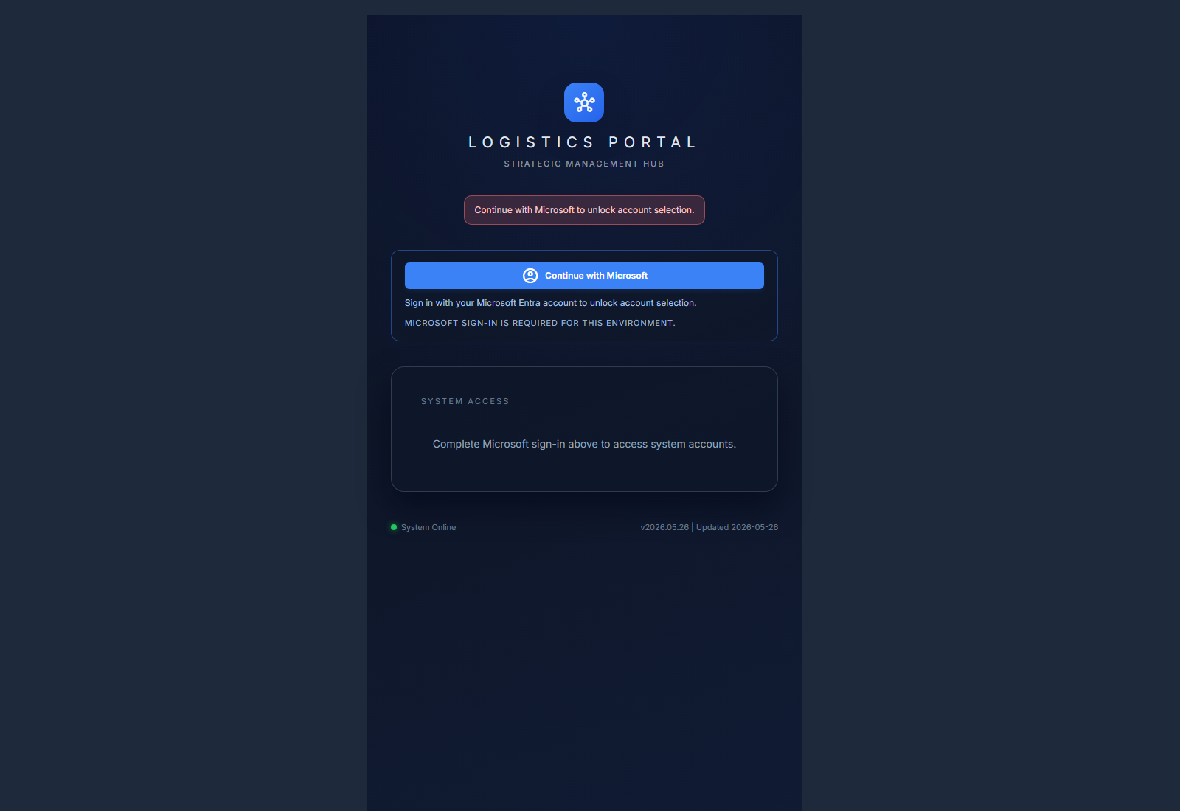
Figure 1. Microsoft Entra sign-in view when SSO is required for the environment.
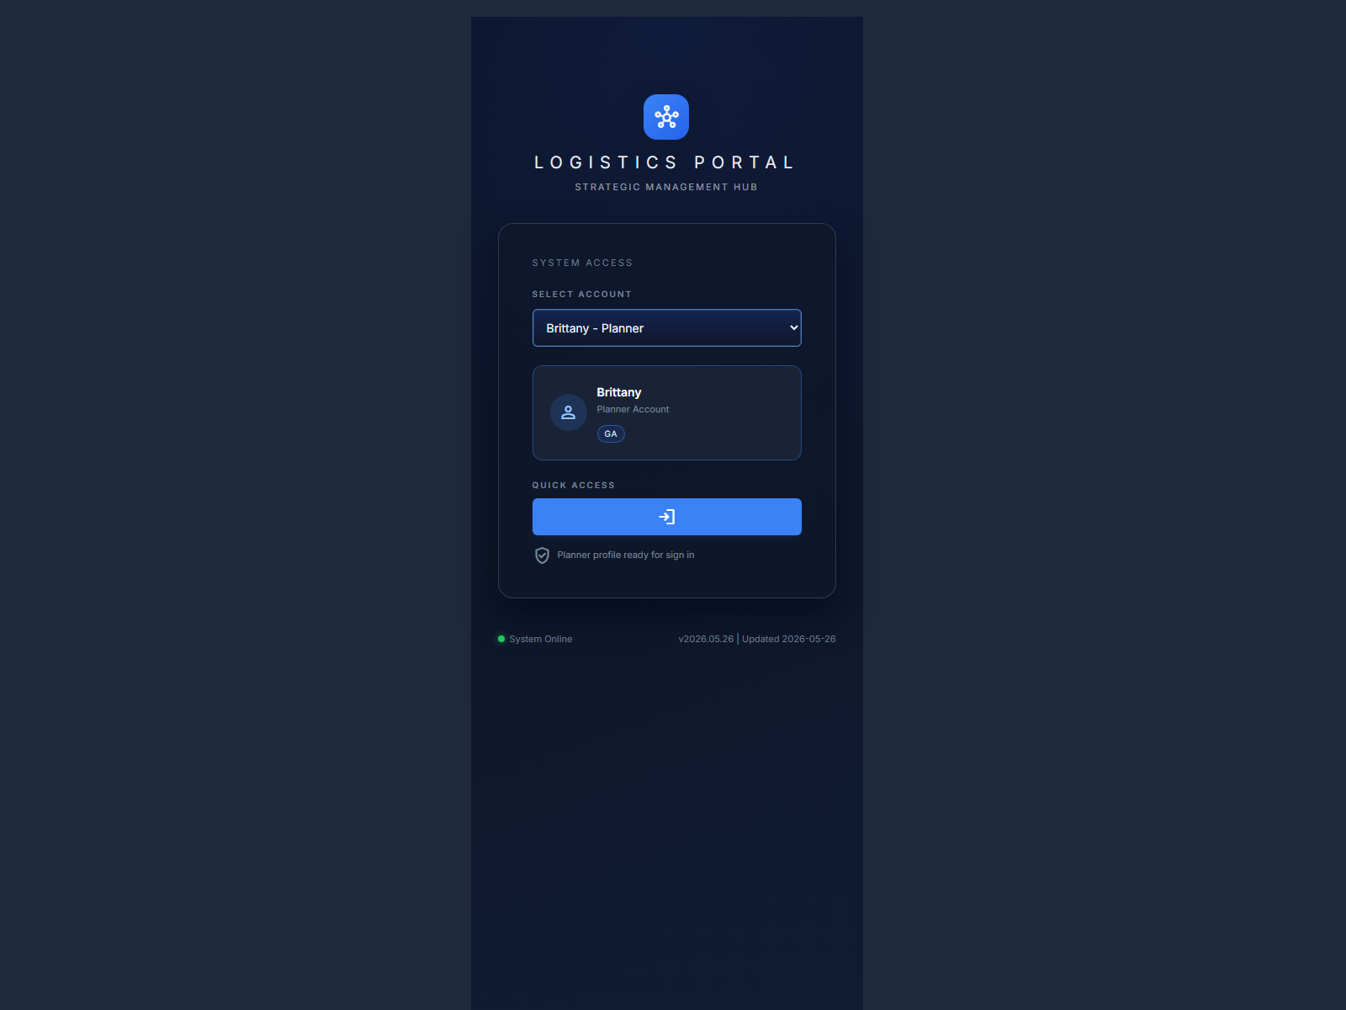
Figure 2. Account-selection view used to choose planner or admin access after sign-in.

Process: Adding or Editing Access Profiles
Admin users manage account access from the profile menu by selecting Manage Profiles. This screen is admin-only and is used to create planner or admin accounts, assign plant access, and maintain Microsoft sign-in mappings.
- Open the profile menu and select Manage Profiles to access the account management screen.
- To add a new account, enter the Profile Name and populate Microsoft Sign-In Emails for any users who should auto-map into that profile after Microsoft Entra sign-in.
- Select the account role: use Admin Account for full access to all plants and settings; use Sandbox Account only for isolated planner sandbox sessions — do not use Sandbox for primary shared planning work.
- For planner accounts, select at least one Allowed Plant. Select Default Focus Plants to control which plants appear by default at sign-in. If left blank, the tool defaults to all allowed plants.
- To edit an existing account, locate the profile in the Existing Profiles table and click Edit. Update the role, plant scope, or Microsoft email mapping as needed, then click Save Changes.
- Review each account's role, plant scope, default focus, Microsoft email mapping, and creation date in the Existing Profiles table before making changes.

Admin note: each Microsoft sign-in email should map to only one access profile. Keep profile names unique to avoid access conflicts.
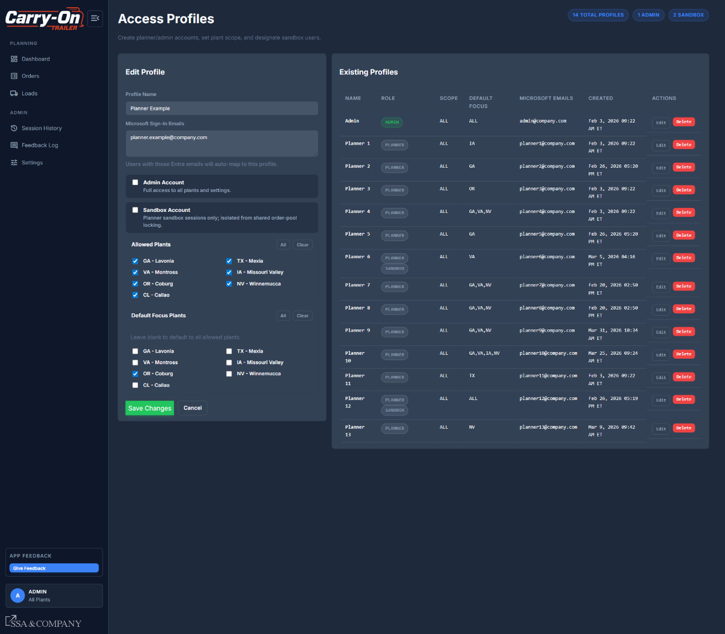
Figure 3. Manage Profiles screen — new account creation on the left and existing access profile review on the right.

Step 2 — Upload Open Orders and Validate Intake Results

1  Open Orders  Data Intake Hub checkpoint | ▶ | 2  Check Freshness  Outdated → refresh first | ▶ | 3  Upload CSV  Latest exported file | ▶ | 4  Review Summary  Counts, discrepancies | ▶ | 5  Resolve Unmapped  SKUs before running

- Open Orders and use the Data Intake Hub as the daily intake checkpoint.
- If the freshness badge shows Outdated, open the refresh guide and follow the SharePoint / Excel macro checklist before uploading.
- Click Upload Orders and select the latest exported CSV. The app validates required columns, plant/item values, SKU mapping, and dimensional readiness used for stacking.
- After processing, review Upload Summary counts: total rows, total orders, mapped percent, unmapped SKUs, new orders, changed orders, reopened orders, closed orders, and unchanged orders.
- Review Load Assignment Discrepancies. This highlights orders taken off loads in the source file and orders that still appear on approved tool loads, so planners can decide whether to release them back for replanning or preserve the current approved state.
- If new or changed SKUs are unmapped or missing required dimensions/stack limits, the upload can block until SKU specs are reviewed and saved.
- Use the Unmapped SKUs panel to approve or enter dimensions, category, and stack assumptions. Saved entries flow into Settings and can then be used to finalize the upload.

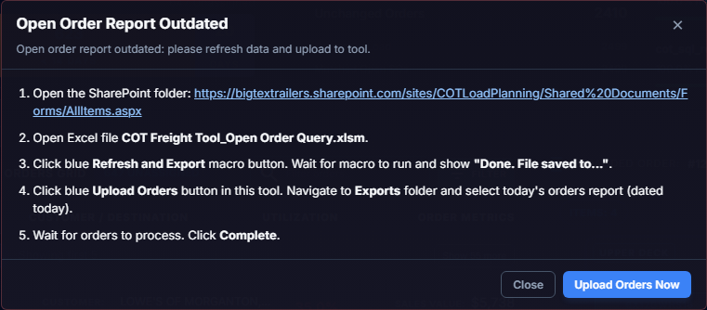
Figure 4. Daily refresh checklist shown when the open-order report is outdated.
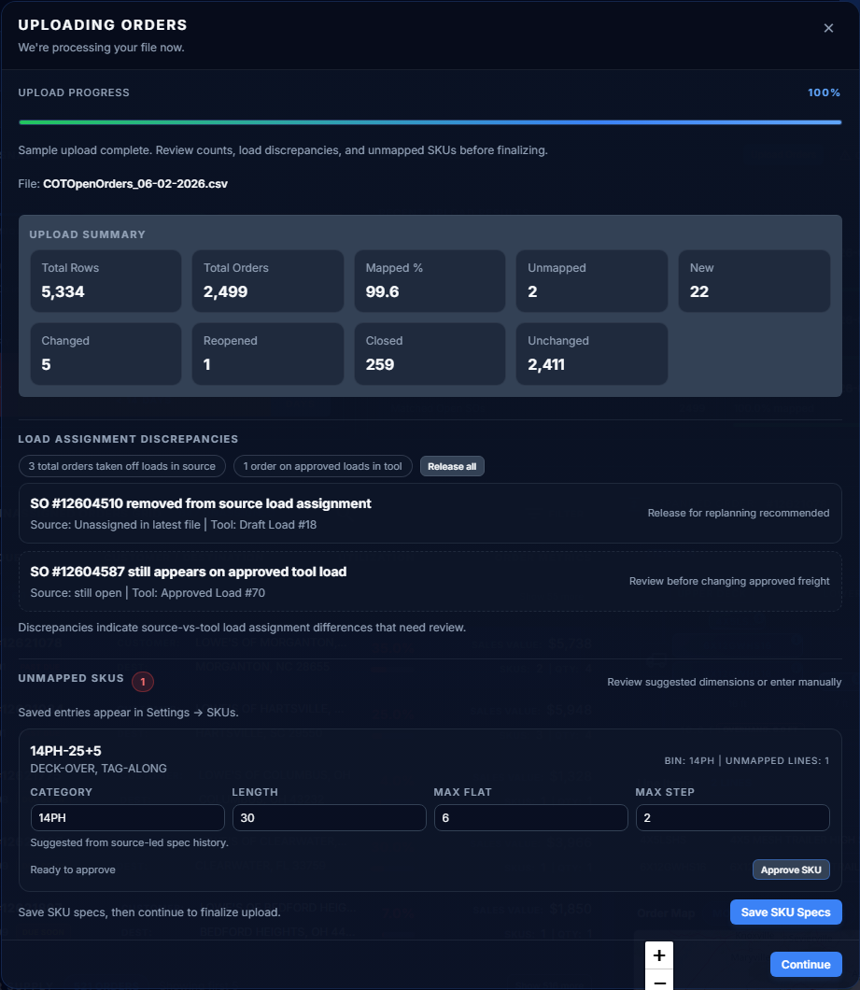
Figure 5. Upload results modal showing summary counts, load-assignment discrepancy review, and unmapped SKU resolution.

Step 3 — Sign In and Confirm Daily Intake Status
Begin each planning day by confirming that order data is current before launching optimization. Stale order data reduces the quality of all downstream load recommendations.

1  Sign In  Confirm plant & session context | ▶ | 2  Open Orders  Check Intake Hub freshness badge | ▶ | 3  Upload CSV  Latest open-order file | ▶ | 4  Review Mapping  Mapped vs. unmapped results | ▶ | 5  Resolve Flags  Fix unmapped SKUs before run

- Sign in and confirm plant and session context.
- Open Orders and check the Data Intake Hub freshness badge — confirm status shows Up to Date before proceeding.
- Upload the latest open-order CSV using the intake controls.
- Review mapped and unmapped order results after upload.
- If unmapped SKUs are flagged, resolve SKU specifications in Settings before running draft loads.

Quality Rule
Run intake first each day. Stale or unmapped order data reduces optimization value and can produce load recommendations that do not reflect current inventory and order status.

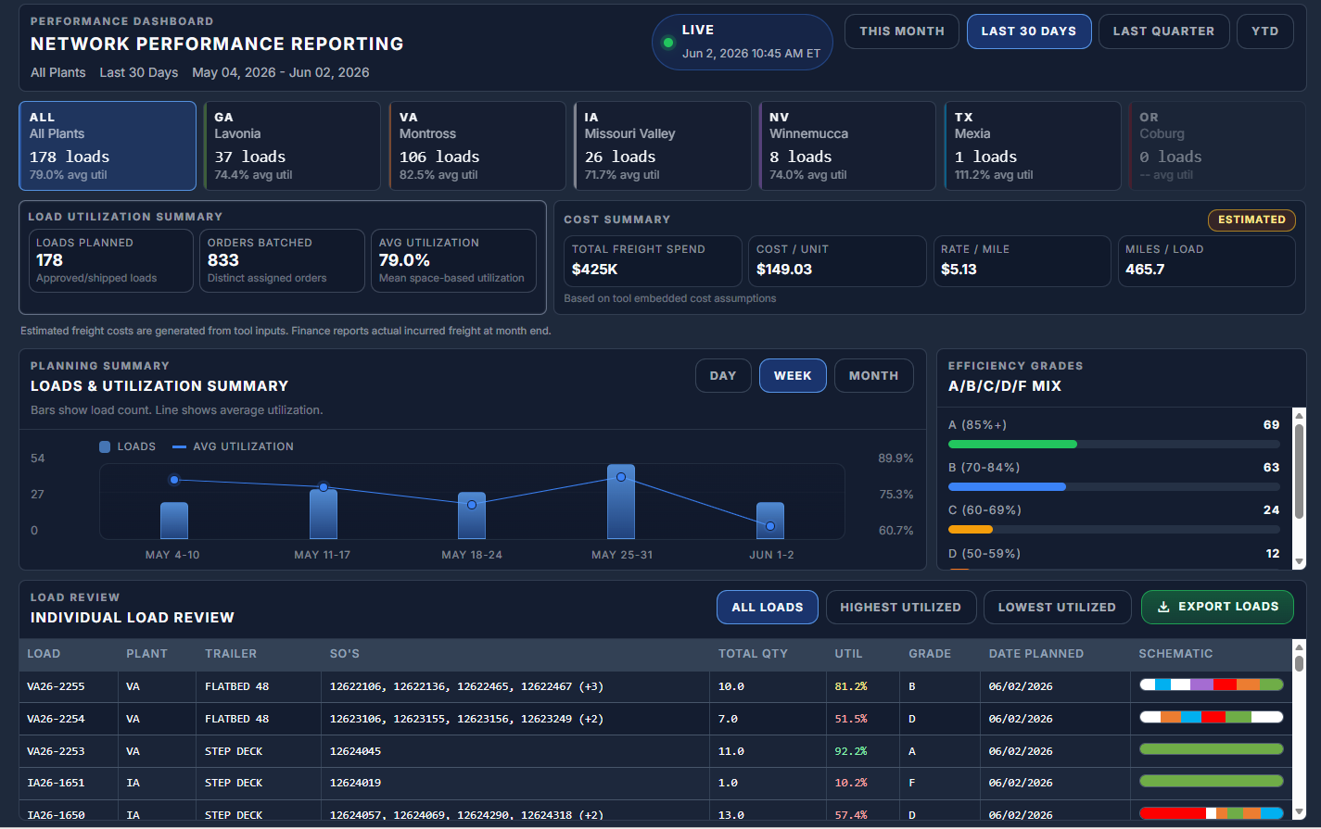
Figure 6. Dashboard workspace — daily planning visibility, session status, and intake freshness indicators.
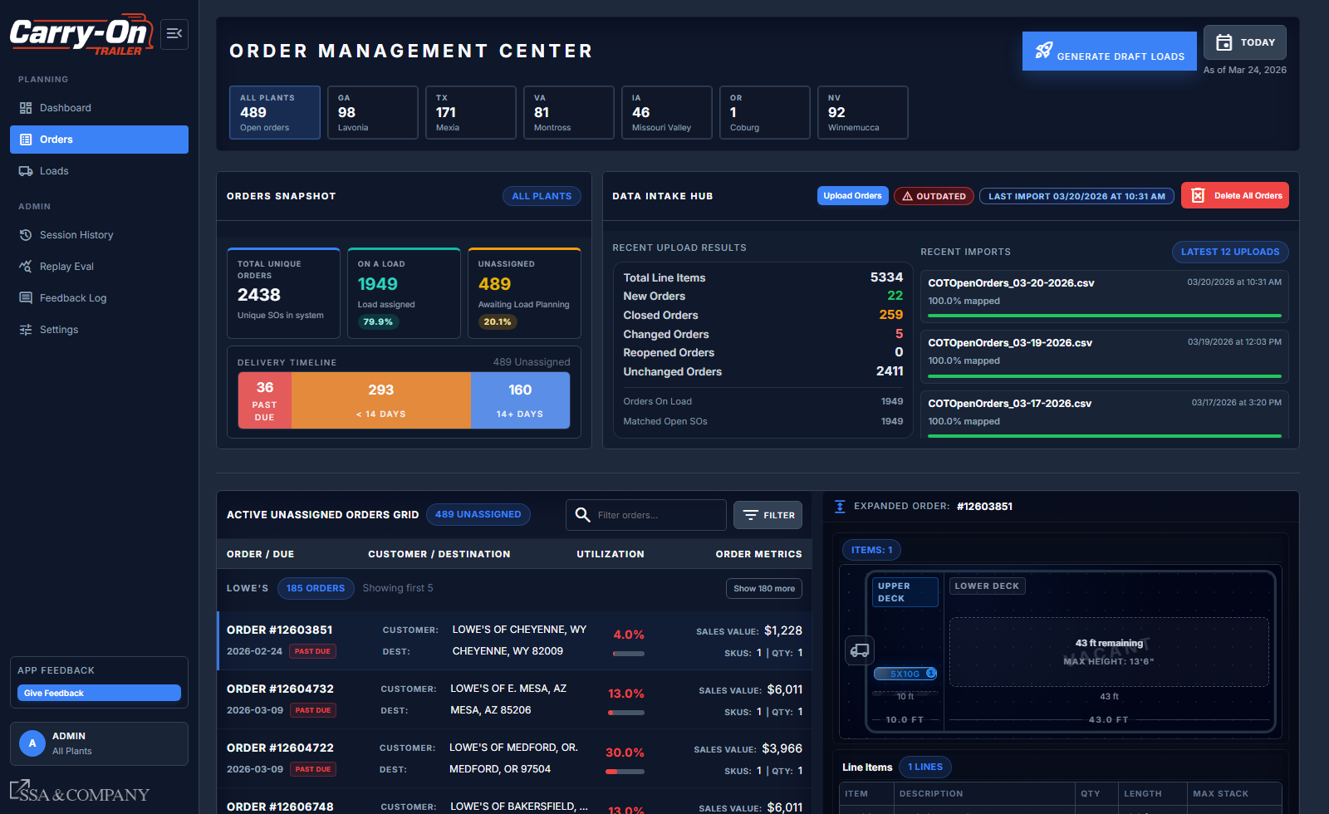
Figure 7. Orders page with Data Intake Hub — freshness badge, upload controls, and mapped/unmapped order review.

Step 4 — Build Draft Loads
COT offers two load-building strategies. Use Auto Optimize for broad daily planning runs across a customer or state scope. Use Paste Orders for controlled, SO-specific builds where the planner selects exact orders.

1  Launch Session  Generate Draft Loads | ▶ | 2  Configure Scope  Plant, trailer, window, customers | ▶ | 3  Select Strategy  Auto Optimize or Paste Orders | ▶ | 4  Run Optimization | ▶ | 5  Verify Counts  Confirm in-scope orders

- From Orders, click Generate Draft Loads to open the Session Config Workbench.
- Set origin plant, trailer profile, scheduling window, customer scope, state scope, and order category scope.
- Select Auto Optimize for broad planning runs, or Paste Orders for controlled SO-specific builds.
- Run the optimization and wait for results to populate.
- Verify the in-scope order count before navigating to Loads to review output.

Auto Optimize vs. Paste Orders
Auto Optimize: the system selects the best order combination across the defined scope. Best for daily broad runs. — Paste Orders: the planner specifies exact sales orders to include. Best for customer-specific or exception builds where order selection needs to be controlled.

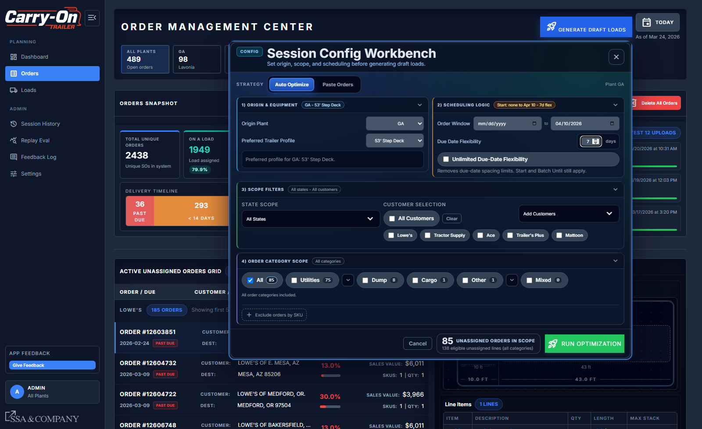
Figure 8. Session Config Workbench in Auto Optimize mode — scope configuration fields and strategy selection.

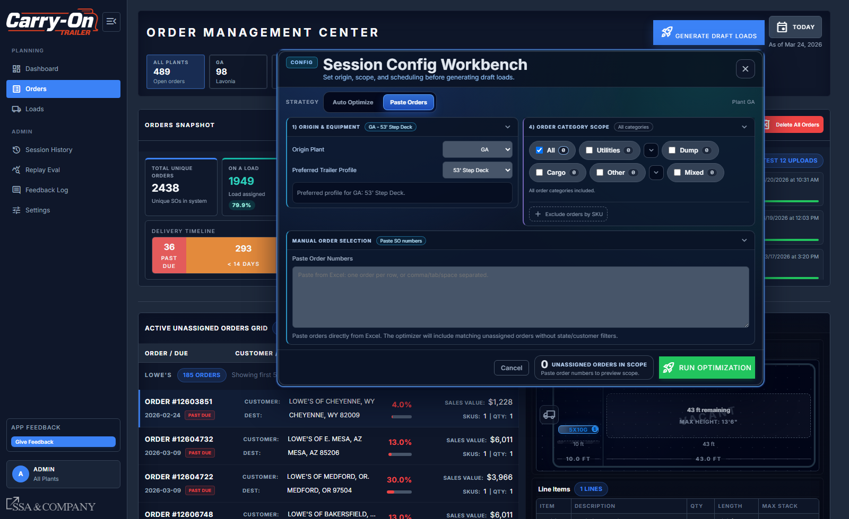
Figure 9. Session Config Workbench in Paste Orders mode — manual order entry and SO-specific build controls.

Step 5 — Review, Edit, and Approve Loads

1  Loads Review  Compare & inspect loads | ▶ | 2  Edit Schematic  Drag units, fix layout | ▶ | 3  Add Orders  Manually Add Orders tool | ▶ | 4  Approve to Draft  Working review stage | ▶ | 5  Approve & Lock  Finalize load numbers

- Use the Loads Review Center to compare draft loads, inspect utilization, warnings, route geography, and freight impact before approving.
- Open a specific load to review route timeline, map, schematic, manifest, utilization grade, estimated miles, and estimated cost in one page.
- Use Edit Schematic from the Loads Review Center to drag units between stacks and decks, reset to the base layout if needed, and save the revised arrangement. The editor surfaces overflow and overhang warnings before save.
- Use Manually Add Orders to search eligible draft-scope orders, preview how added freight changes the footprint, and add selected orders into the current load.
- Use the Trailer Type dropdown to switch trailer profiles when a different deck geometry or capacity is needed. This directly affects stacking and utilization calculations.
- Use Reverse Sequence when the stop order needs to be flipped before approval.
- Use Approve to Draft during working review, then Approve and Lock when the load is ready to finalize. Approved loads become read-only for key layout actions until they are moved back to draft.

Before Final Approval
Validate route sequence, schematic warnings, and utilization grade before locking. Approved and locked loads require a return-to-draft action before any further edits can be made.

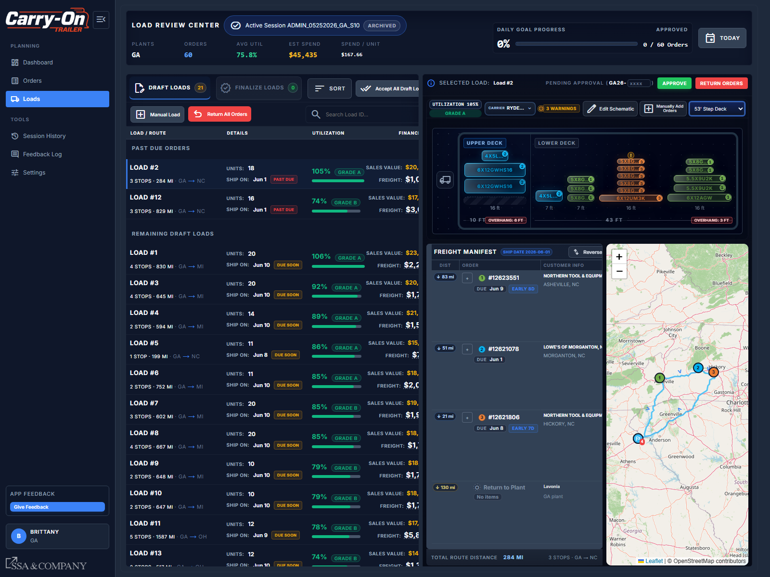
Figure 10. Load detail view — route map, schematic layout, utilization score, and approval controls.

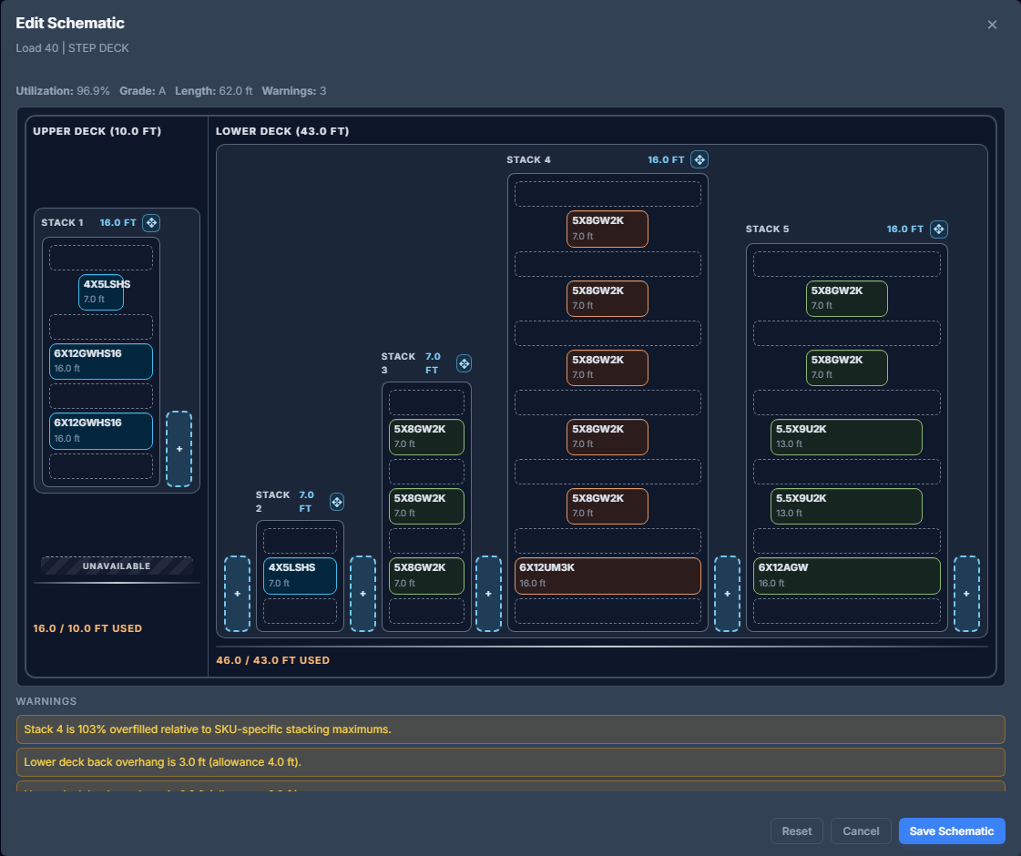
Figure 11. Edit Schematic modal used to reposition units and resolve fit issues before saving.
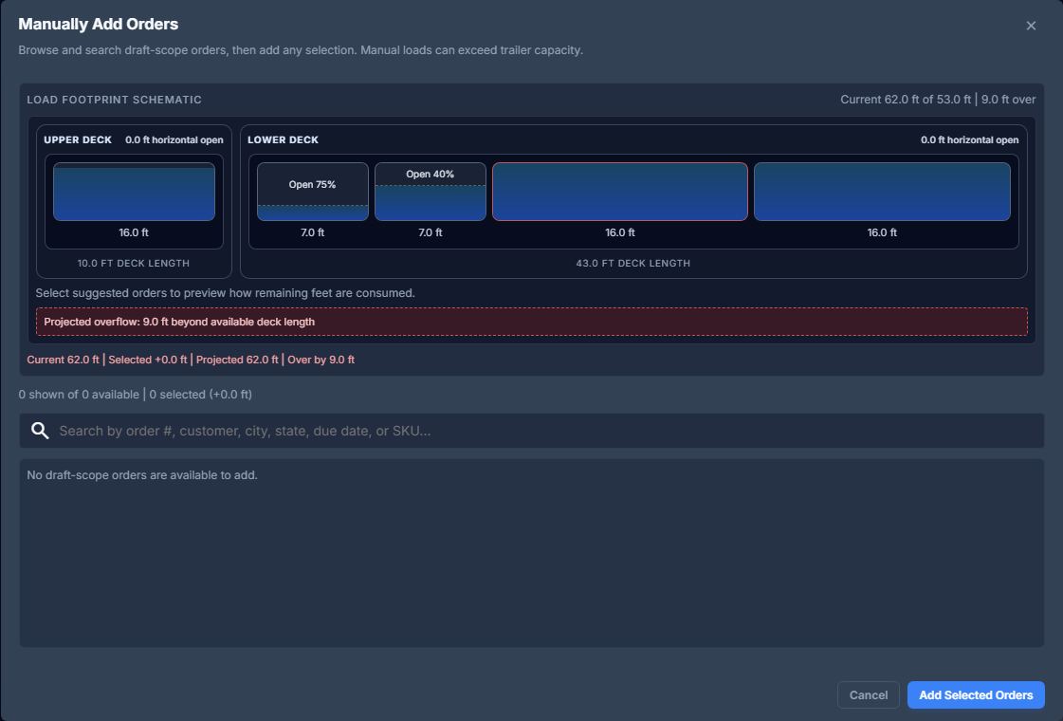
Figure 12. Manually Add Orders modal used to preview footprint impact before adding draft-scope orders to the load.

Step 6 — Maintain Settings and Planning Assumptions
Settings are the operational knowledge base behind optimization quality. Each settings area controls a different dimension of load planning logic and should be treated as controlled operational data.

1  Command Center  Fees, minimums, plant defaults | ▶ | 2  Rates  Lane economics & carrier matrix | ▶ | 3  SKUs & Lookups  Dimensions & mapping logic | ▶ | 4  Save Changes | ▶ | 5  Re-Validate  Affected planning sessions

- Use Command Center to maintain stop fees, load minimums, fuel surcharges, grade thresholds, and plant defaults.
- Use the Rates tab to maintain lane economics and carrier matrix assumptions.
- Use the SKUs and Lookups tabs to keep item dimensions, stack behavior, and intake mapping logic current.
- Save each edited section individually before navigating away.
- Re-open and re-validate affected planning sessions after any settings change that may impact optimization output.

Quality Rule
Inaccurate settings propagate directly into utilization scores, route economics, and candidate load decisions. Treat all SKU, rate, and lookup edits as operationally significant changes.

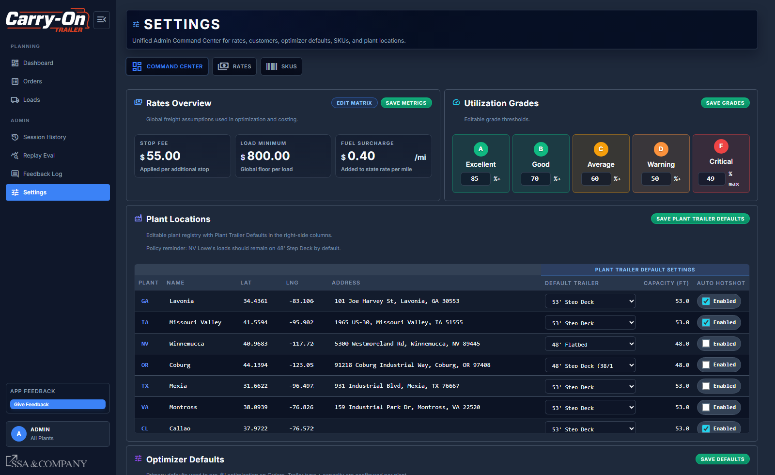
Figure 13. Settings Command Center — global optimizer parameters, stop fees, and plant-level defaults.

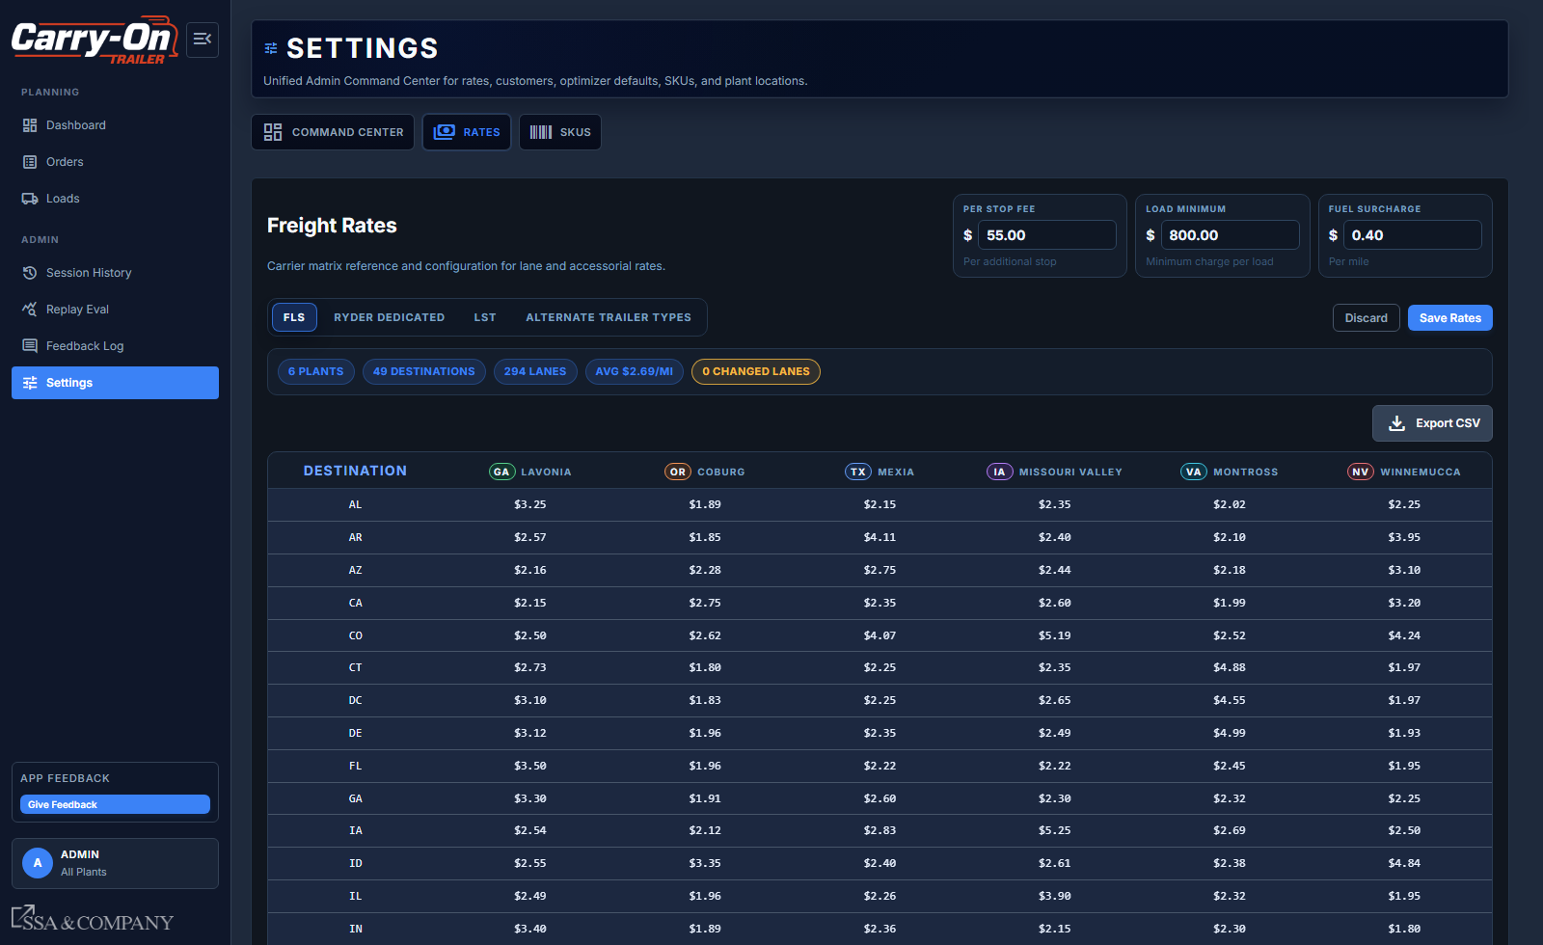
Figure 14. Rates tab — lane-level freight matrix with carrier and origin/destination configuration.

Step 7 — Use Session History, Reports, and Exports
Session History preserves the full context of each planning run, enabling planners to resume incomplete work, audit prior decisions, and maintain continuity across planning cycles.

1  Open Session History | ▶ | 2  Filter & Find  Date, plant, or status | ▶ | 3  Resume or Audit  Draft work or prior runs | ▶ | 4  Load Report  Summarize approved loads | ▶ | 5  Export Excel  Hand off to fulfillment

- Open Session History to access all prior and active planning sessions.
- Filter by date, plant, or status to locate the relevant session.
- Resume draft work or audit prior runs by opening the session detail.
- Use Load Report to generate a summary of approved loads with route and utilization context.
- Use Export Excel to produce operational hand-off files for fulfillment teams.

Use Session History Instead of Recreating Runs
If a planning session was partially completed or needs to be revisited, always resume from Session History rather than starting a new session. This preserves parameter context and prevents duplication of load recommendations.

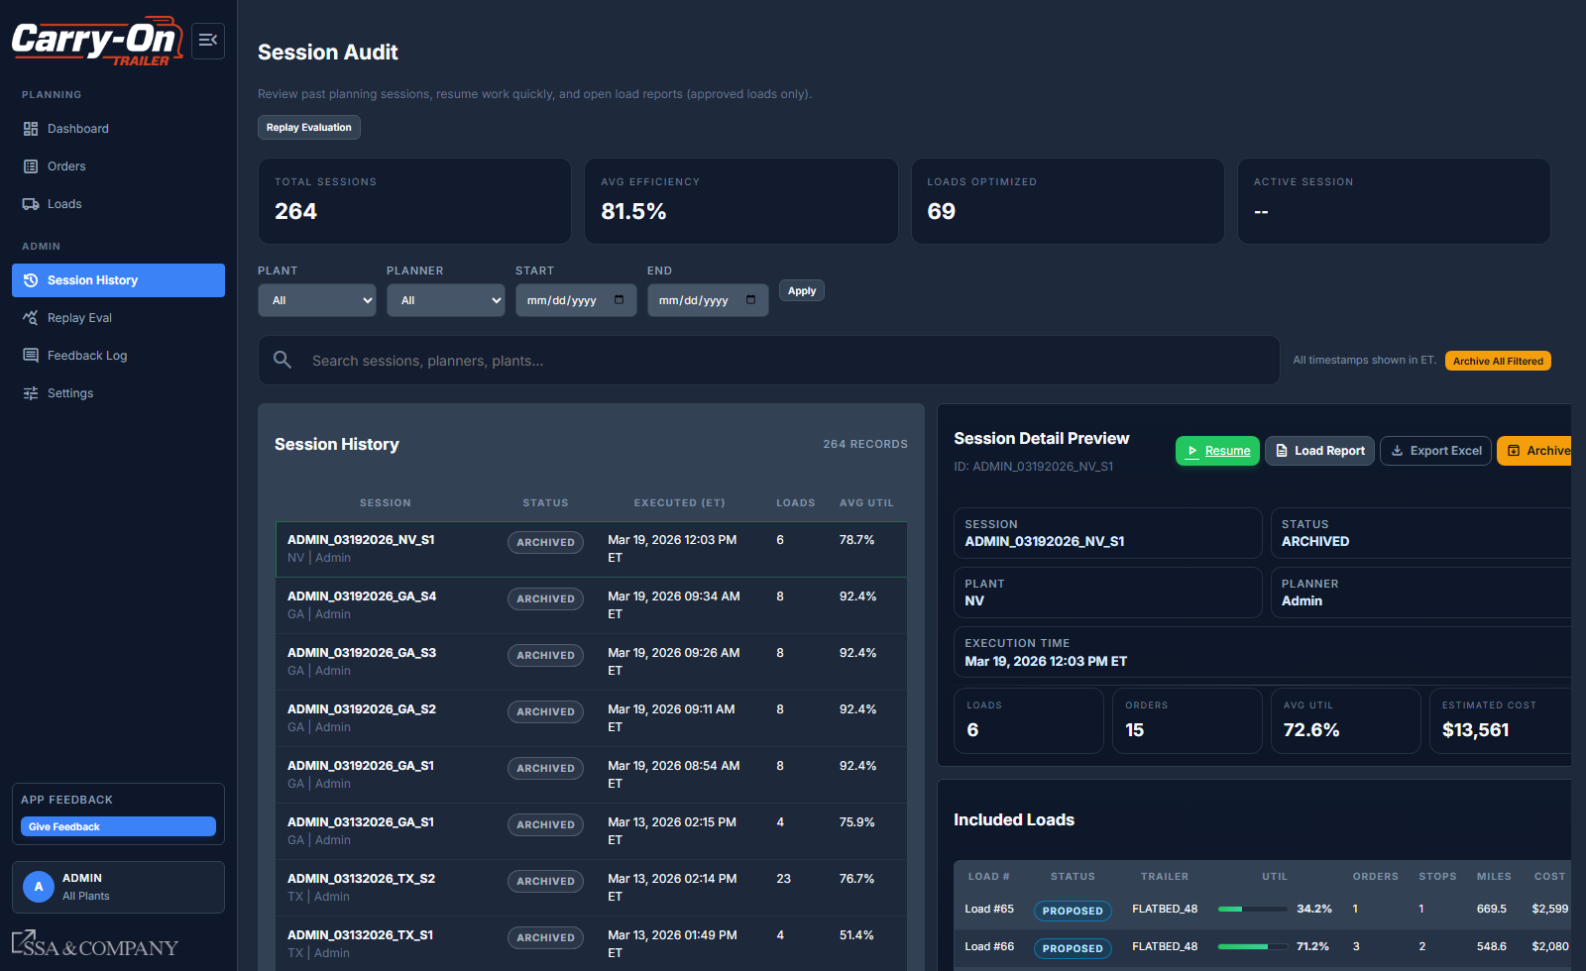
Figure 15. Session Audit page — filter and search controls for navigating historical planning sessions by date, plant, and status.

Settings and Assumption Management

Settings are the operational knowledge base behind optimization quality. Inaccurate assumptions propagate directly into utilization scores, route economics, and candidate load decisions. All settings changes should be treated as controlled operational data updates.

What Is Configured in Settings
- Rate matrix by origin plant and destination state
- Stop fees, load minimums, and fuel surcharge cost assumptions
- SKU dimensions, stack heights, and footprint logic
- Item-to-SKU lookup mappings used during intake normalization
- Plant trailer defaults, capacity profiles, and optimizer defaults
- Utilization grade thresholds applied across Orders, Loads, and reports

Process: Adding or Editing SKU and Lookup Data

1  Open Settings | ▶ | 2  Navigate to Tab  SKUs or Lookups | ▶ | 3  Search First  Avoid duplicates | ▶ | 4  Apply Edits  Dimensions, stack rules, mappings | ▶ | 5  Save & Re-Validate  Refresh affected sessions

- Open Settings and navigate to the SKUs tab or Lookups tab where changes are needed.
- Search existing records first to avoid creating duplicates or conflicting mappings.
- Apply edits to dimensions, stack rules, and lookup relationships.
- Save changes using the section-level save control.
- Re-open impacted planning sessions and re-check fit and utilization behavior before the next optimization run.

Quality Rule
Treat every SKU, rate, or lookup edit as an operationally important change. Incorrect assumptions cascade directly into load recommendations, utilization scores, and cost outputs across all sessions that use that data.

How Optimization Depends on Settings Quality

Settings Area | What It Drives | Risk if Outdated
SKU dimensions and stack rules | Schematic layout and utilization scoring | Incorrect fit recommendations and inaccurate utilization grades
Lookup mappings | Order intake normalization and SKU resolution | Unmapped orders excluded from optimization runs
Rate matrix and surcharges | Estimated freight cost outputs | Cost visibility is inaccurate; approval decisions are made on stale economics
Trailer defaults and capacity | Optimizer scope and load capacity assumptions | Loads may be built against incorrect trailer parameters

Operational Guardrails and Common Mistakes

Guardrails
- Use COT tool as decision support, not as a compliance or regulatory authority. Final shipping release requires carrier judgment and route review.
- Run daily intake before every optimization session. Stale data degrades load quality across the entire planning run.
- Confirm trailer profile and session scope before running optimization; changing parameters after a run requires a new session.
- Treat all SKU, rate, and lookup edits as controlled operational data changes with downstream impact.

Common Mistakes to Avoid

Mistake | Risk | Prevention
Skipping daily intake or using stale order data | Optimization runs on outdated orders; load recommendations do not reflect current state | Check Intake Hub freshness badge before every run; upload new CSV if Outdated
Running optimization with unmapped SKUs | Unmapped orders are excluded from the run; loads are incomplete | Resolve all SKU mapping flags in Settings before launching the session
Editing loads after Approve and Lock without returning to draft | Changes are blocked; edits attempted on locked loads produce errors | Return load to draft status before making any edits post-approval
Starting a new session instead of resuming from history | Parameter context is lost; duplicate load recommendations may be generated | Always resume incomplete sessions from Session History
Treating cost outputs as final freight quotes | COT cost estimates use internal rate assumptions, not confirmed carrier pricing | Validate estimated costs against current carrier rates before communicating externally

Quick Reference Tips
- Run intake first each day; stale order data reduces optimization value across the entire session.
- Use Paste Orders mode when a controlled, SO-specific build is required rather than a broad optimization run.
- Before final approval, validate route sequence, schematic warnings, and utilization grade.
- Use Session History to resume partially completed work rather than recreating sessions from scratch.

